PIF: Project progress report
By: Zaslavskyi Dmytro


Content List:
- Planner Tool
- Raspberry Pi
- PVC Holder
- Database
- Printed Circuit Board
- Power Supply
- Sensors 1
- Website(Work In Progress)
- Planner Tool:
For the project I have chosen the “Microsoft Planner” tool in order to organize my work and schedule tasks effectively. Large flexibility of functionality allows me to comfortably check my schedule, track my progress with the project and prepare for the upcoming tasks and challenges that may arise.
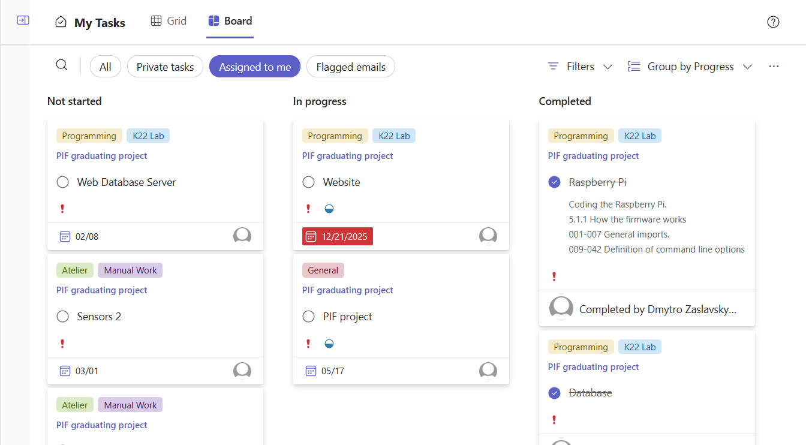

- PIF – Raspberry Pi Sprint


Table of Contents:
- Assembly of the Raspberry Pi…………………………………………………1
1.1. Attaching the screen……………………………………………………….1.1
- Programming Raspberry Pi…………………………………………………….2
2.1. Installing the operating system and SSH keys………................2.1
2.2. Setting up Interface and Hostname…..………………………………2.2
2.3. Activating I2C interface…………………………………………………..2.3
2.4. Installing Docker…………………………………………………………...2.4
2.5. Uploading firmware………………………………………………………..2.5
2.6. Creating container………………………………………………………...2.6
2.7. Creating autostart script………………………………………………...2.7
- Proof of work………………………………………………………………………3

1.Assemlby of Raspberry Pi:
1.1We had to attach the screen to the Raspberry Pi as follows.
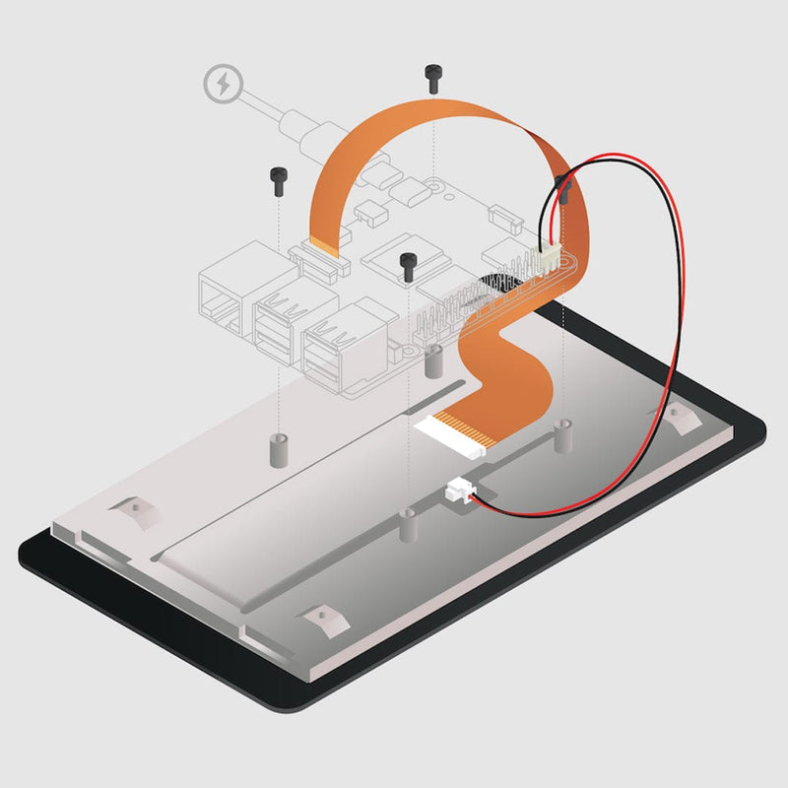
End result:
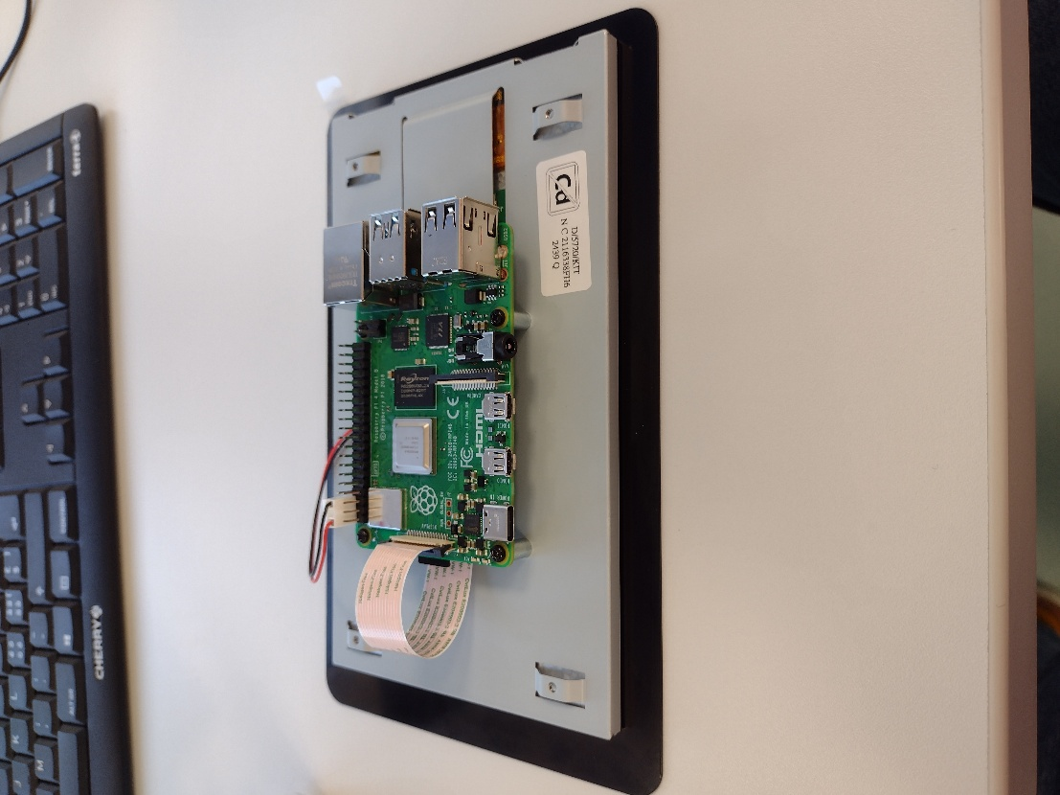
2.Programming raspberry Pi:
2.1. Installing Operating System and SSH Keys:
To install Operating System and enable SSH we had to use RaspberryPi Imager application, gave us a possibility to upload ISO on the SD card and preconfigure RaspberryPi. With screenshots below the following preconfiguration was set.
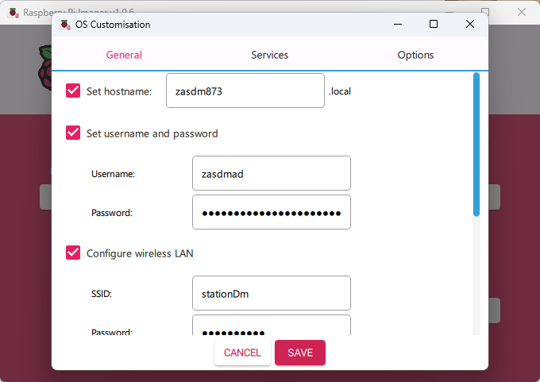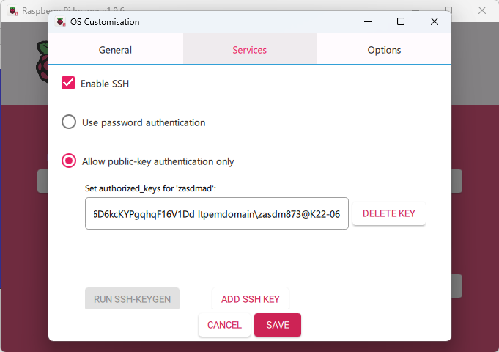
To configure SSH keys I have used Windows cmd command ssh-keygen and pasted it into the field.
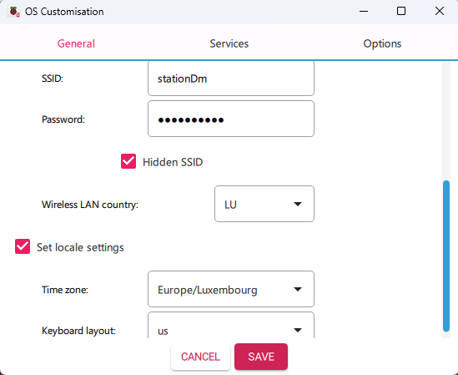

2.2. Setting up Interface and Hostname:
To change hostname and to set up static IP I have used sudo raspi-config command. It opened a setup interface where I chose network settings.
It opened a menu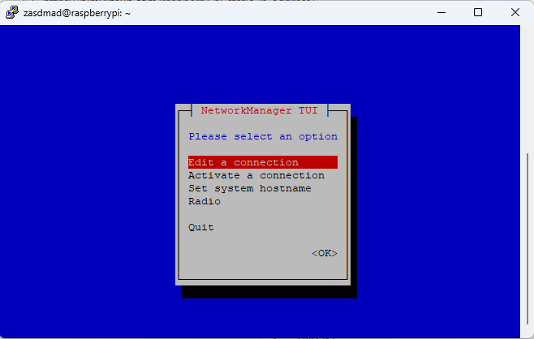
After the window popped up I chose “Edit a connection” Parameter. Then a new window popped open. 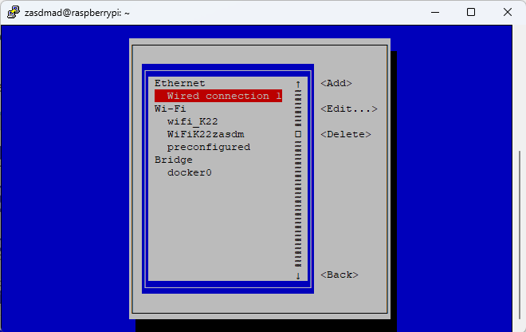
In this window I chose “Wired connection” as it is intended to be plugged into the network and proceeded to set the IP address. 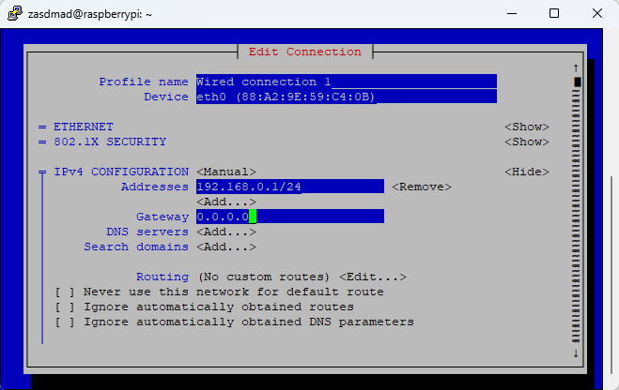
To set the hostname I used the same interface as was shown, but pressed “Set system hostname”. 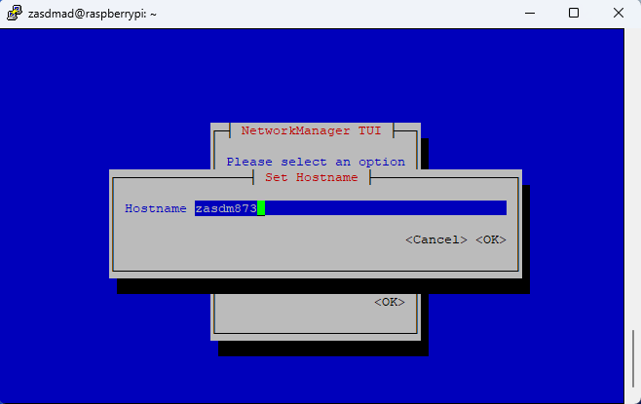

2.3. Enabling I2C interface:
I have enabled I2C with “sudo raspi-config nonint do_i2c 0” where “nonint” means “no interface” and 0 enables the option, because 0 means “true” in RPI.
2.4. Installing Docker:
I downloaded Docker from get.docker.com by installing it as .sh script and executing it with ./get.docker.sh.
2.5. Uploading firmware:
To upload firmware I used winSCP connected to my Raspberry Pi. Before that I created 2 directories /opt/station and /var/station where the firmware files are now stored. After that I downloaded php and apache2 by writing sudo apt install apache2 && sudo apt install php to allow the container to work with php and host a webpage on apache2.
2.6. Setting up a Container:
To create a Container I used the command provided in the assignement and to check if it is running I used sudo docker ps.
2.7. Creating autostart script:
To set an autostart docker docker I inputted the next commands into the file:
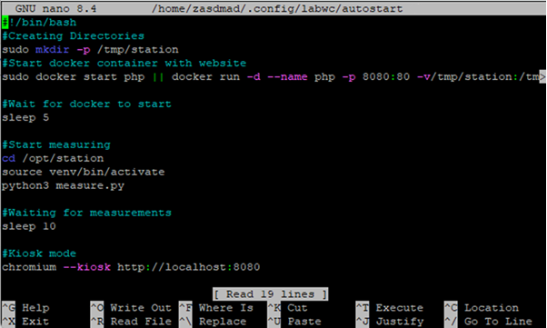
Which creates directory on the first line. Automatically starts the container, boots firmware and enables Kiosk view on the webpage.
3. Proof of Work:
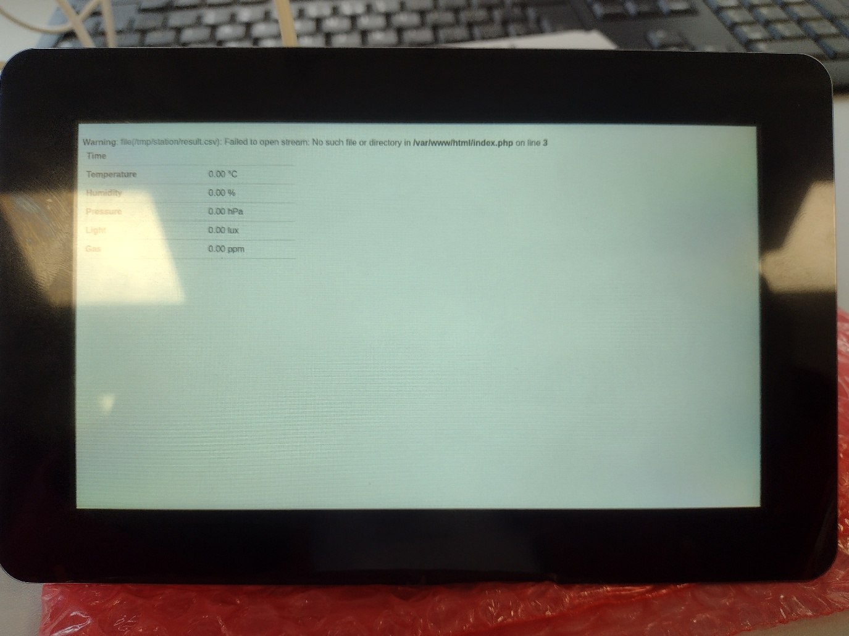
Unfortunately due to misconfiguration I was not capable of outputting sample data, which made the raspberry pi screen blank.

- PVC Holder
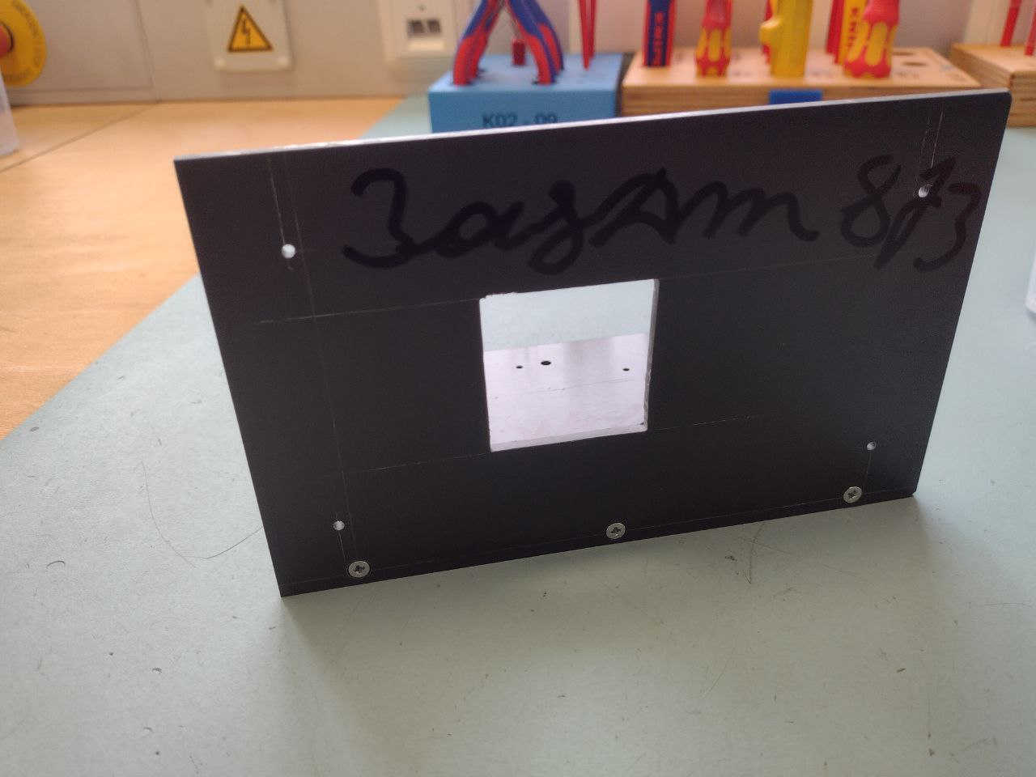
Following schematics provided to us I started with outlining by scratching lines on PVC panels. After making the lines I made hole markings and after that I started drilling. After I drilled the small 2.5 mm holes in frontal and bottom plates I made 3mm holes. After that I proceeded to file the square hole in the middle of the frontal panel and finished it off by drilling horizontal holes in thick plate
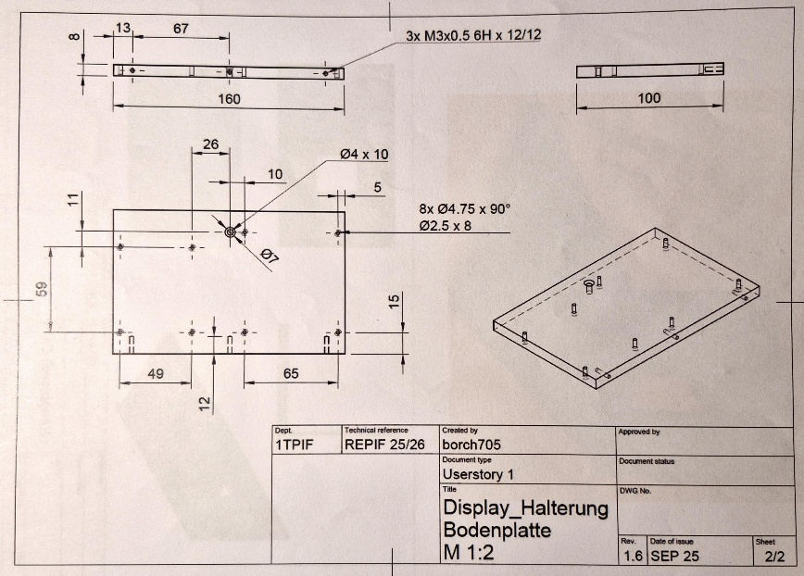
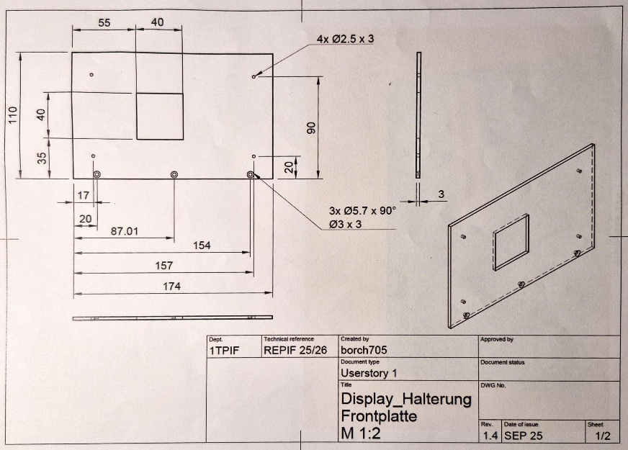

Proof of work:
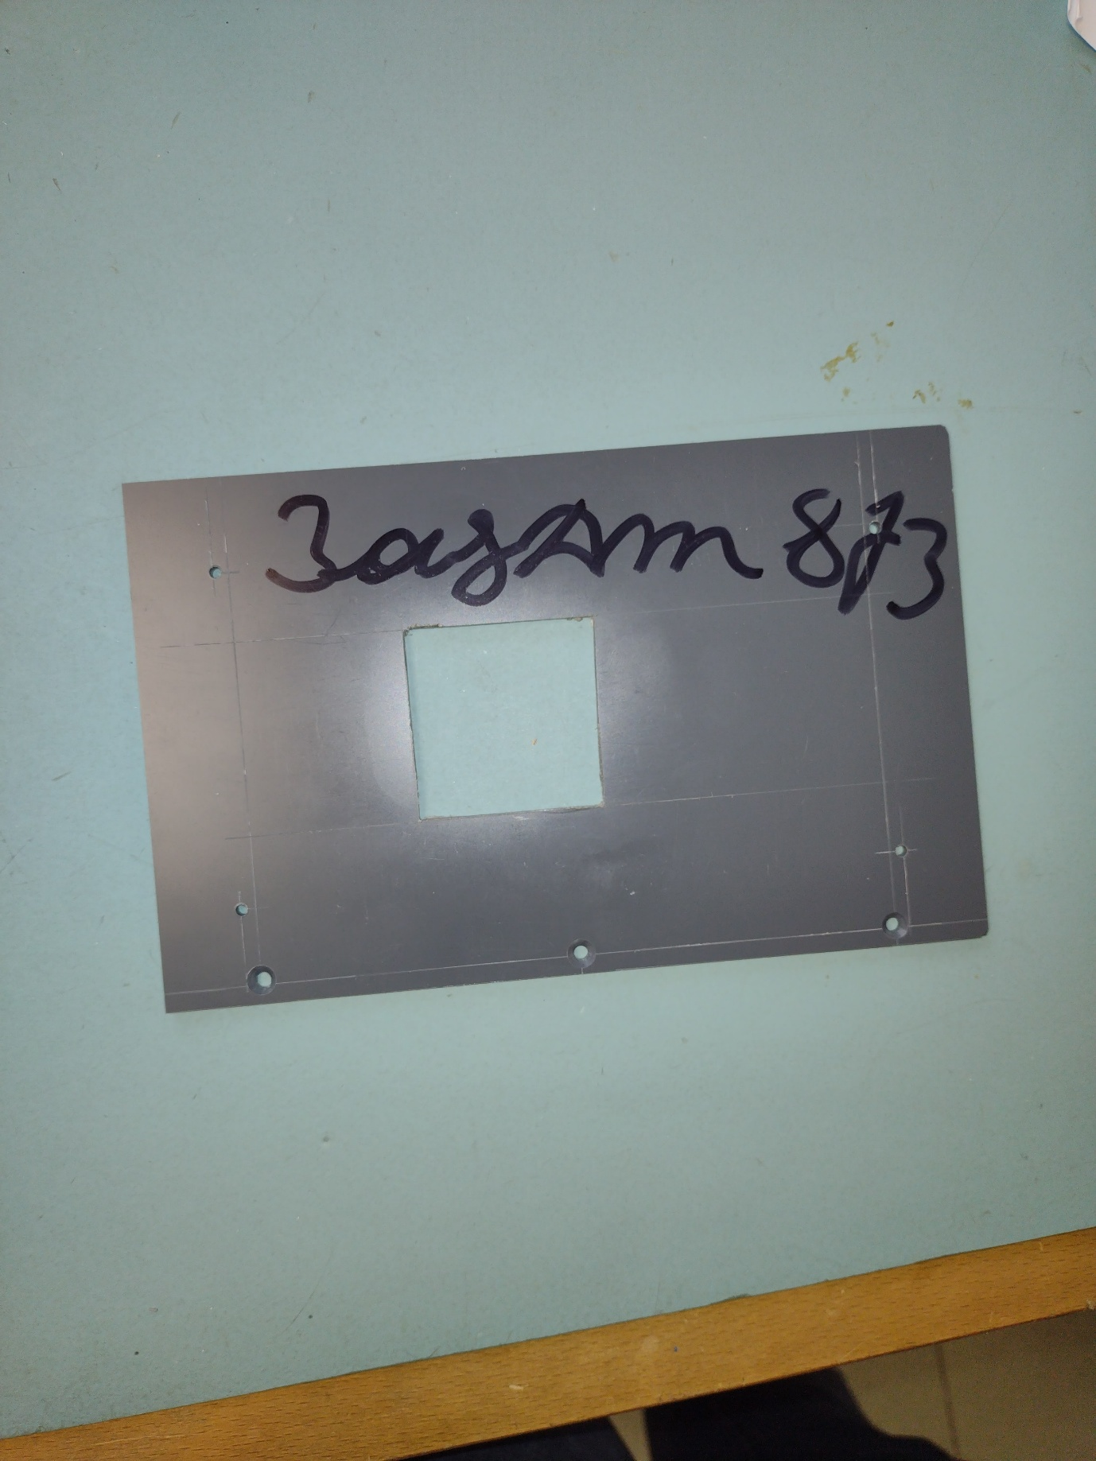
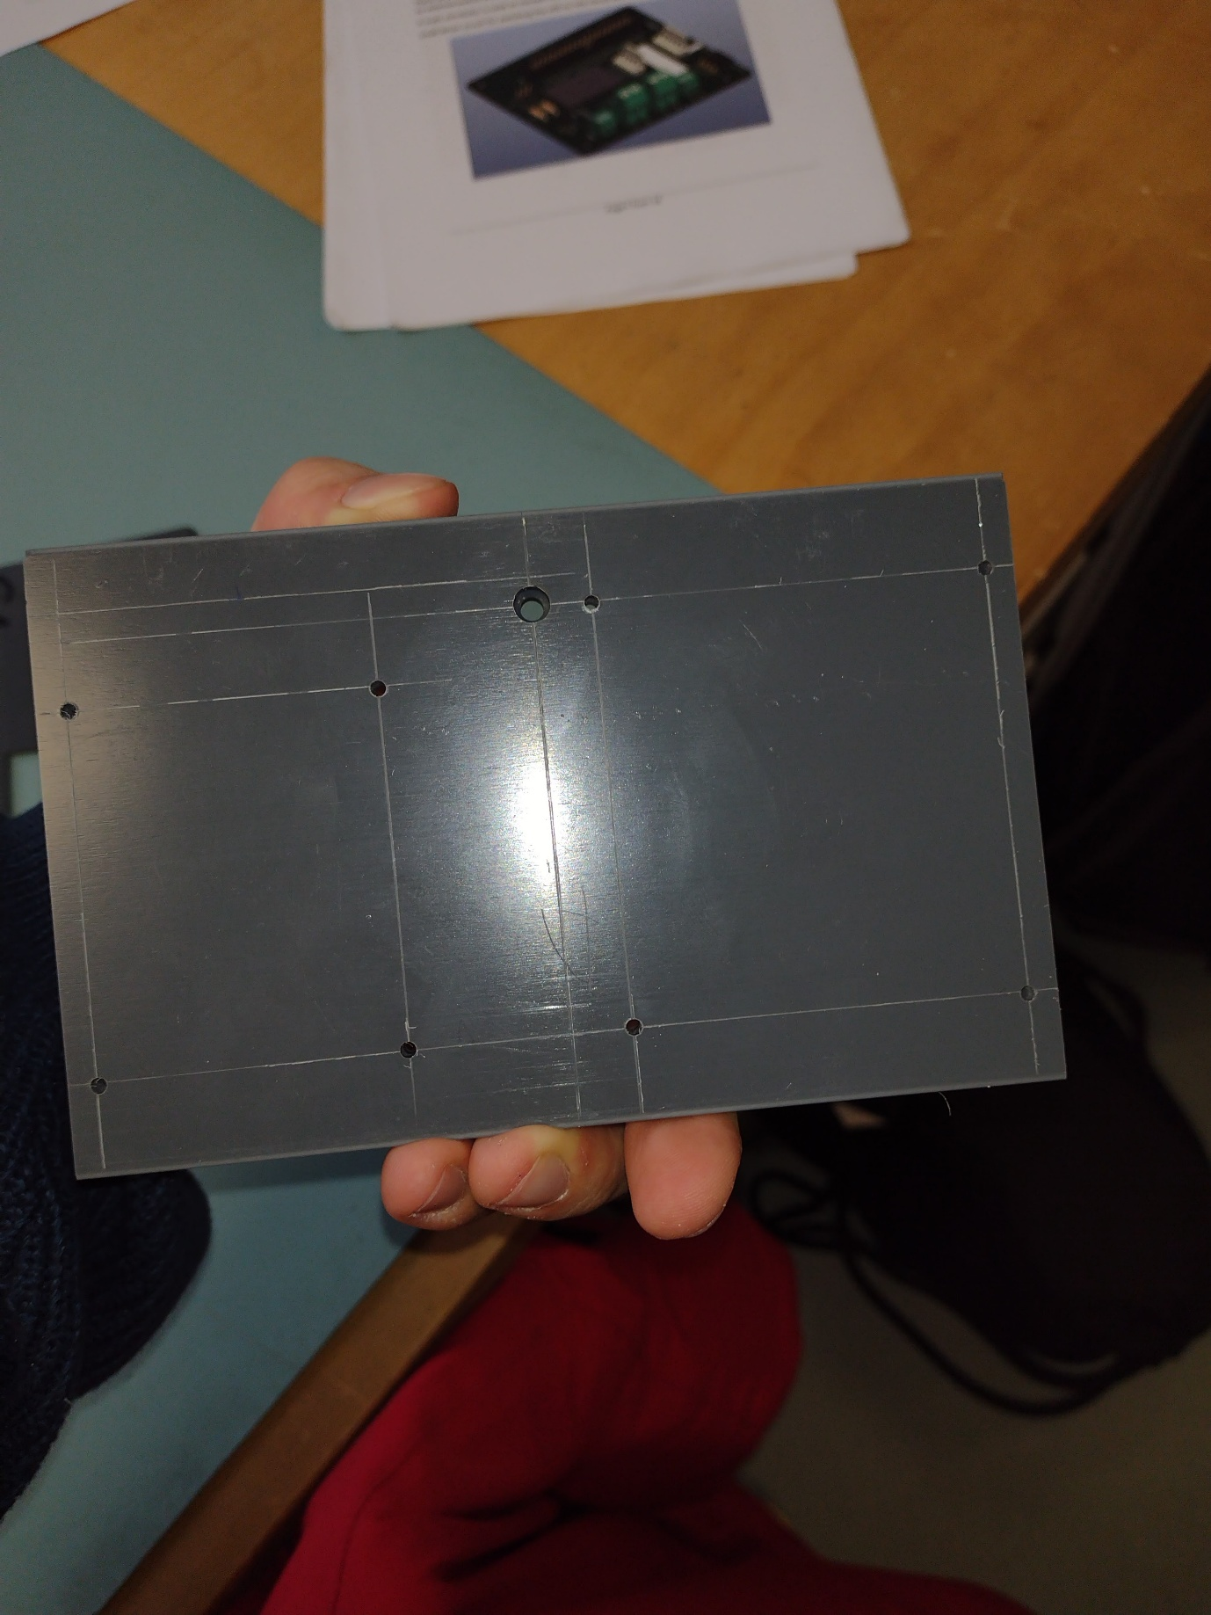

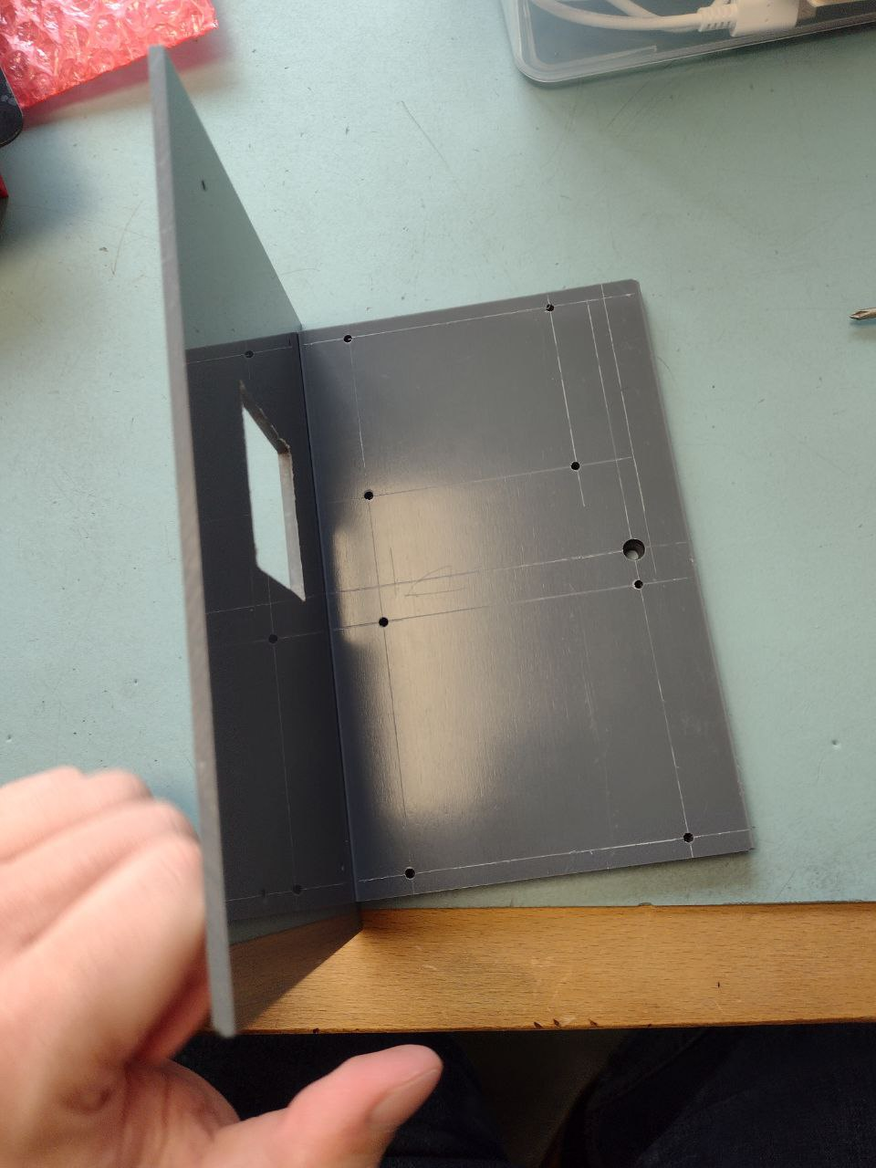

- Database
Conceptual database model:
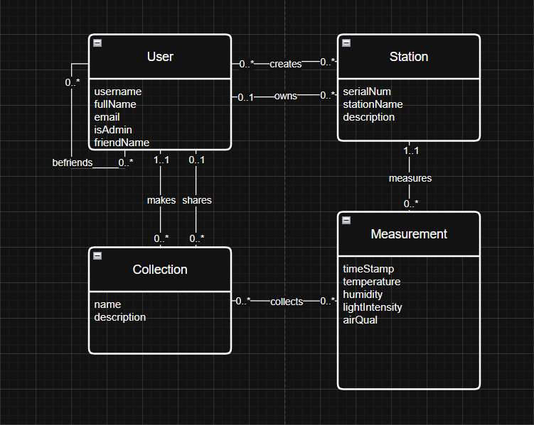
Logical Database model:
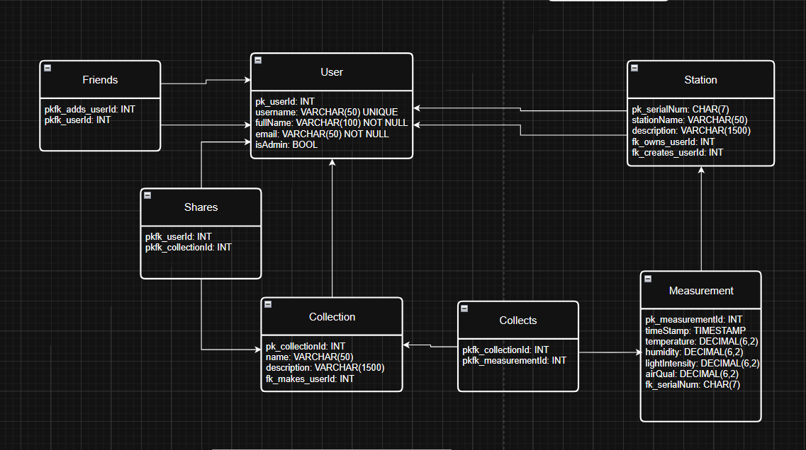

- Printed Circuit Board
PCB plate:
I started first with assembling the printed circuit board.
Step by step I soldered pieces onto it. I started with materials below:
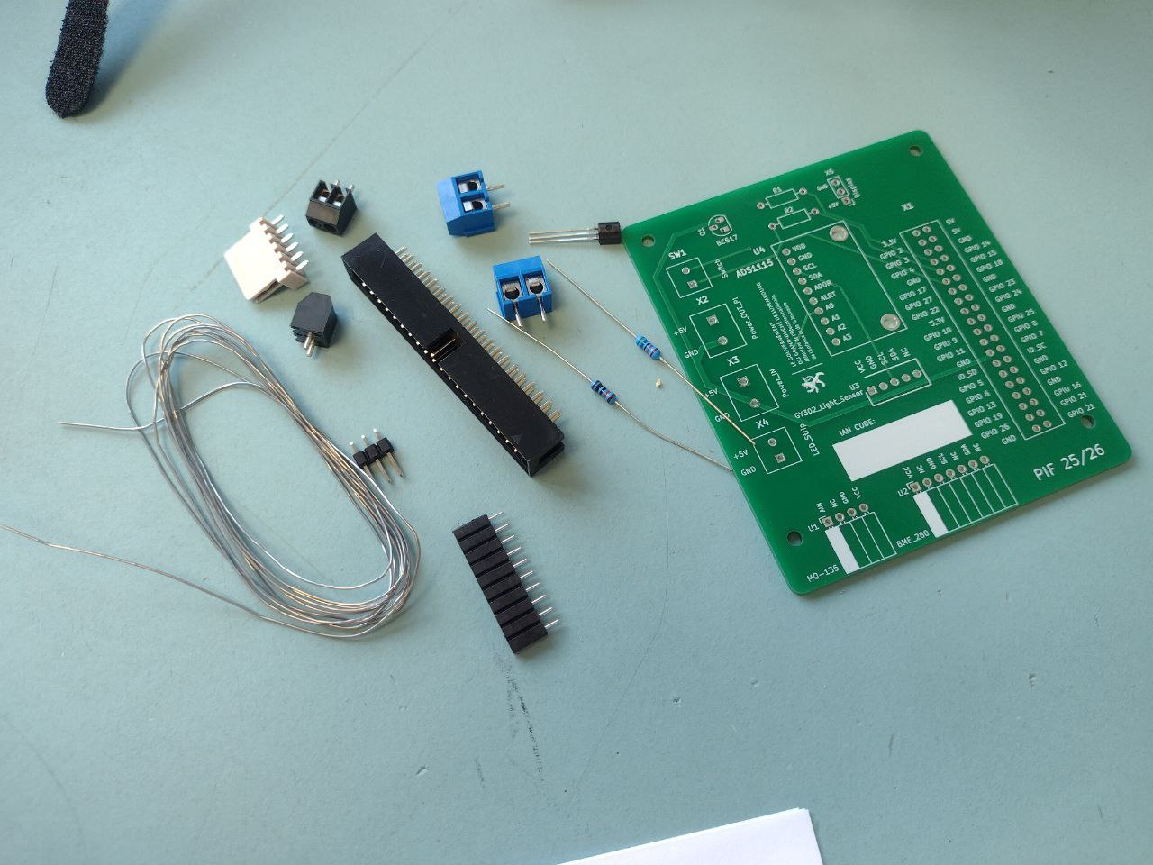
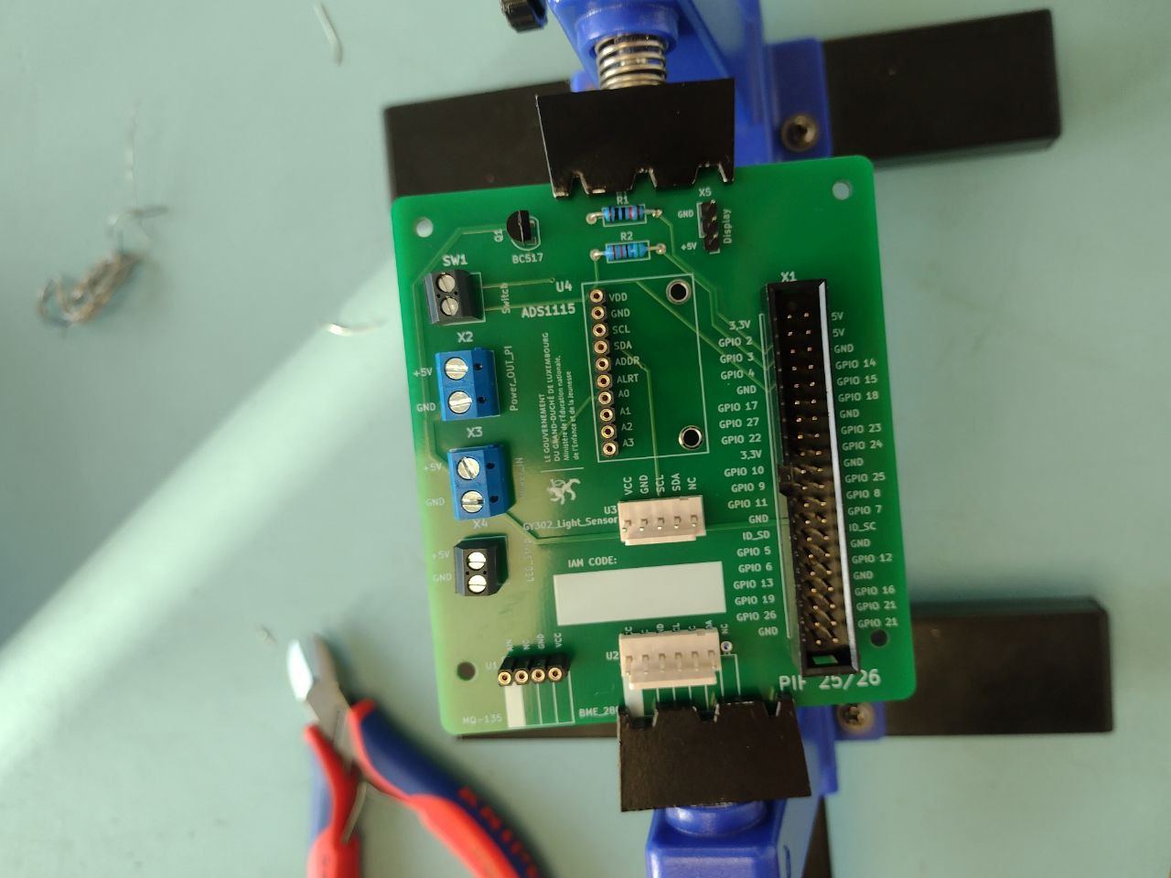
After heating up soldering machine I started to solder the blue and black controllers with 10 pin connectors in the center.
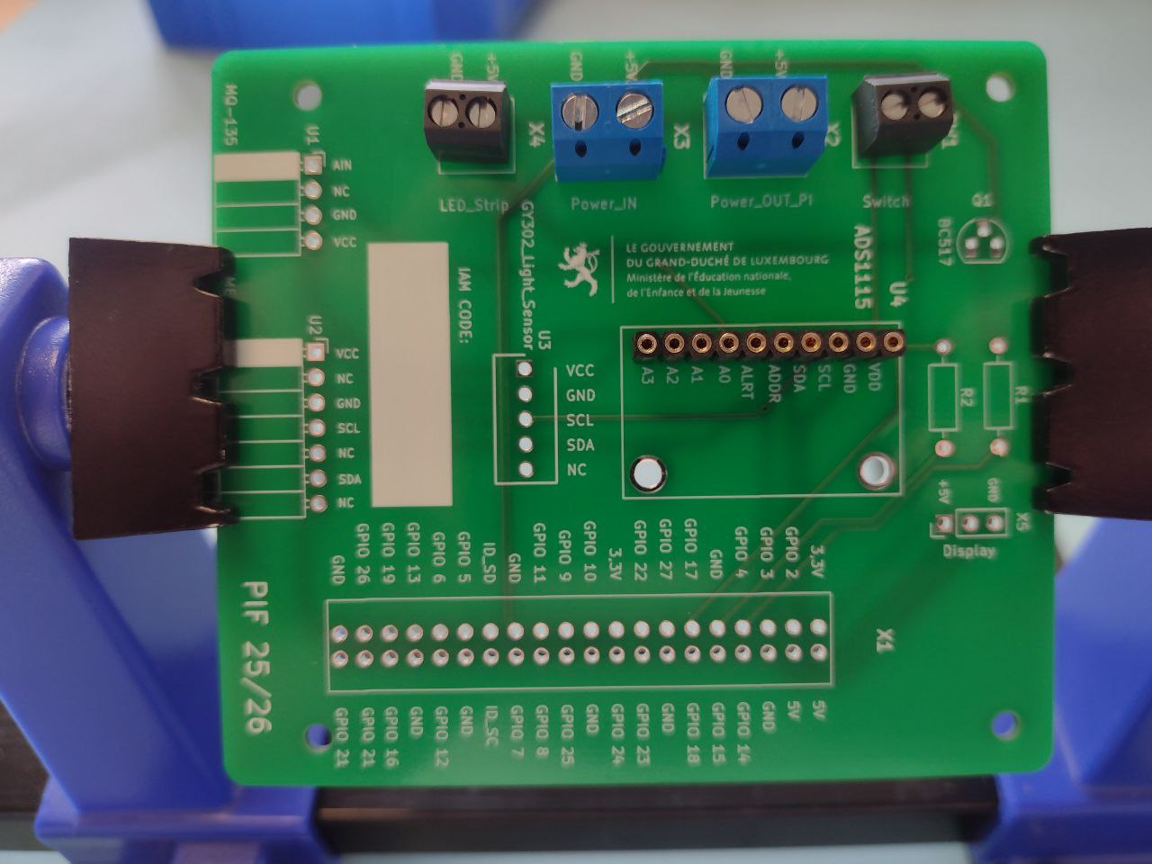
I continued my assembly of circuit board and continued to attach more parts of it, receiving the end result below:

PVC assembly:
Afterwards, I attached PCB board and raspberry pi to the PVC board using 5 mm spacers.
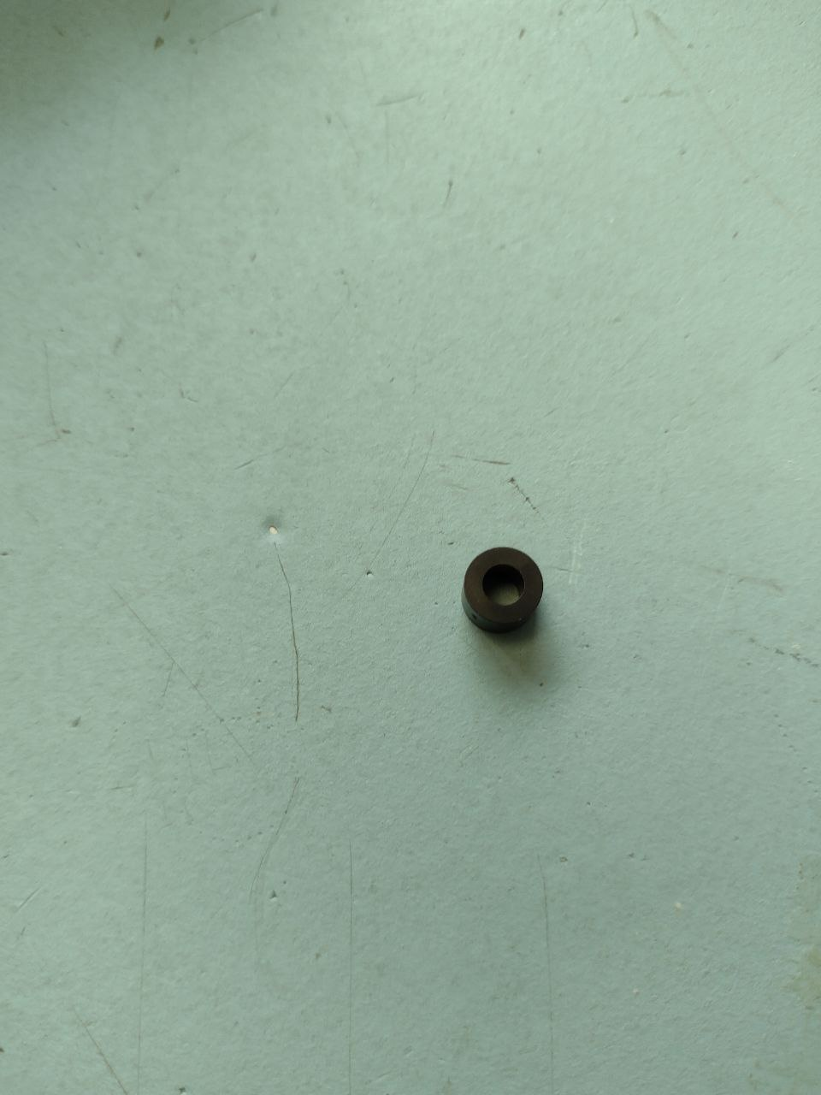
End result:
Due to the PVC Holder sliding while drilling I have run into a problem that my boards and screen can not be completely attached to the Holder.
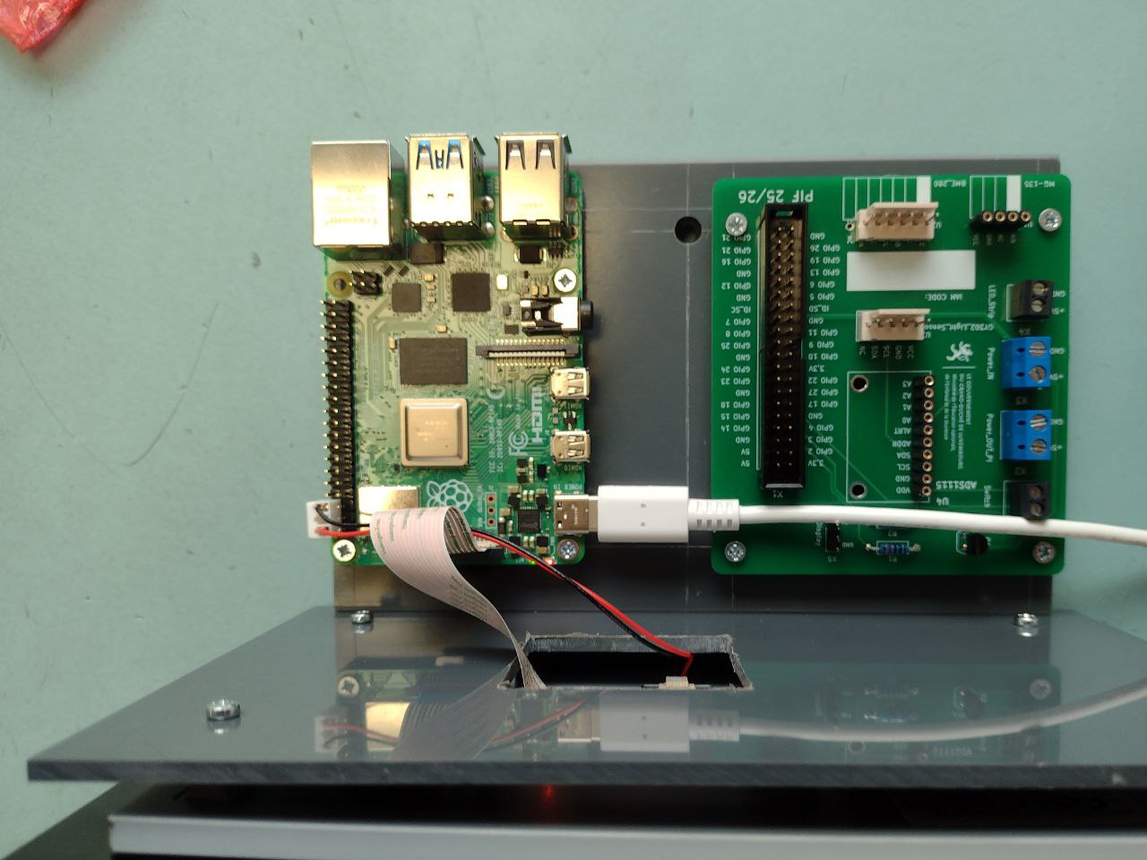

- Power Supply
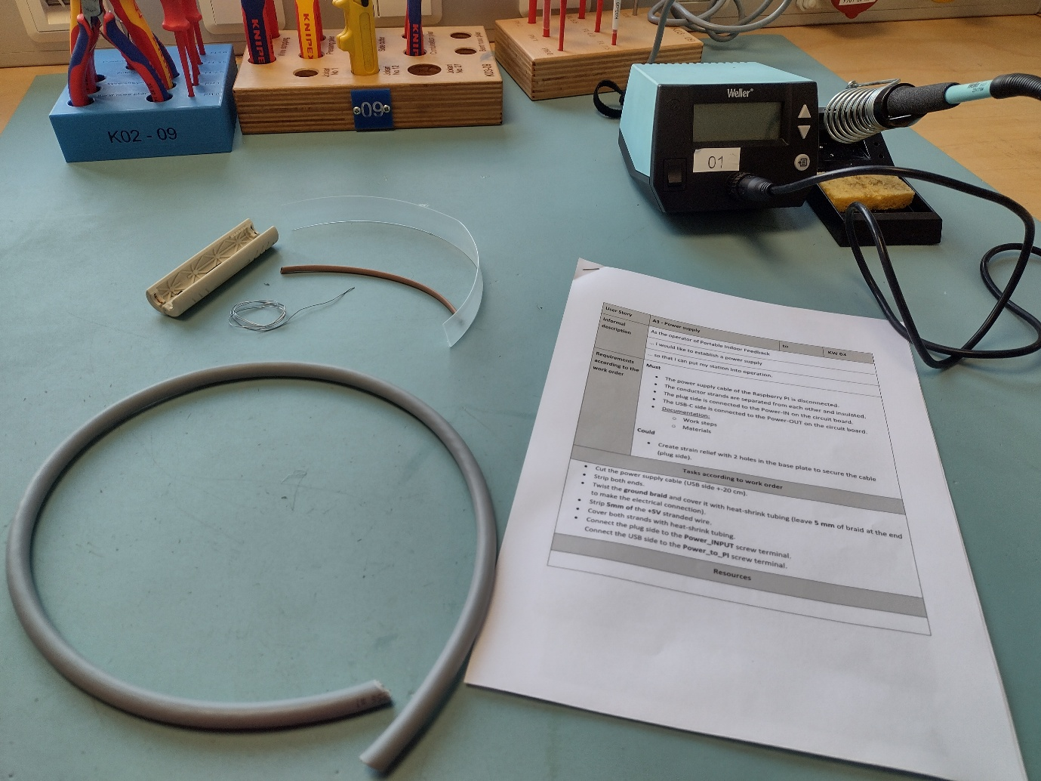

Introduction:
In this userstory our task was to create a new wire for the power supply. Due to the expensiveness of Raspberry Pi power supplies and a high risk of failure, we instead were demonstrating our ability to – remove isolation, solder copper wires and put necessary protections to prevent possible damages. List of equipment involved:
- 1x wire stripping cylinder.
- 1x large copper wire.
- 1x soldering apparatus.
- 1x stripe of soldering steel.
- 1x transparent shrinking isolation tube.
- 1x brown shrinking isolation tube.
- 1x manual.


1st step:
First step to accomplishing the task was to remove isolation from the first layer of the wire, pulling wire shielding and braiding it out.
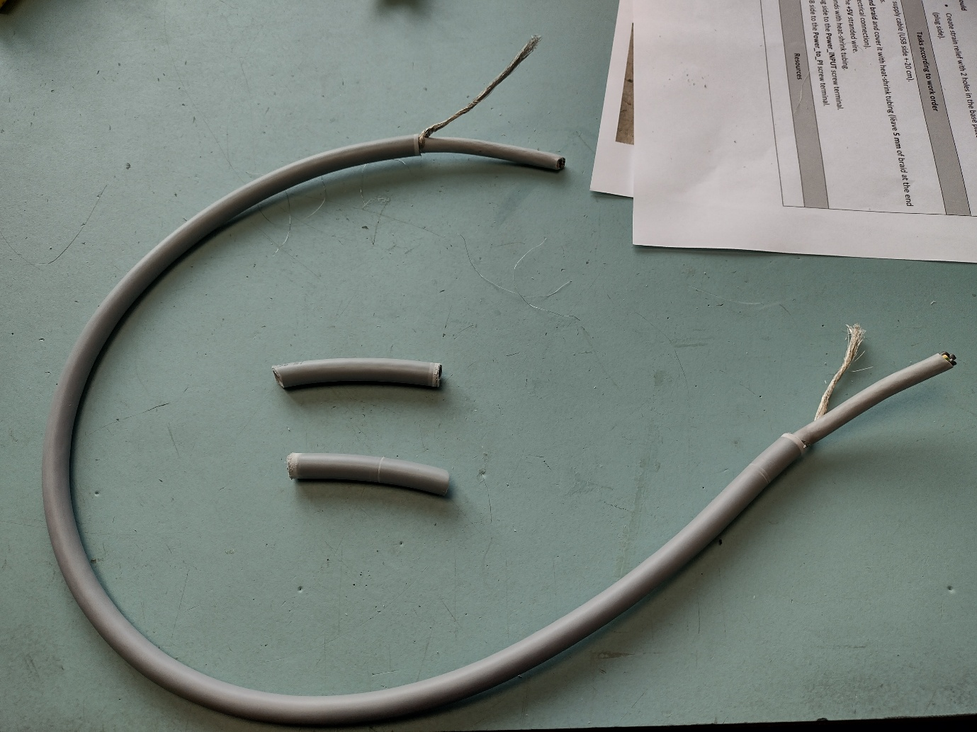

2nd step:
Second step to accomplishing the task was to continue removing isolation until we reach the 4 copper wires. Grounding and 1st,2nd and 3rd phases. After that we had to remove isolation of those 4 wires and prepare them for soldering.
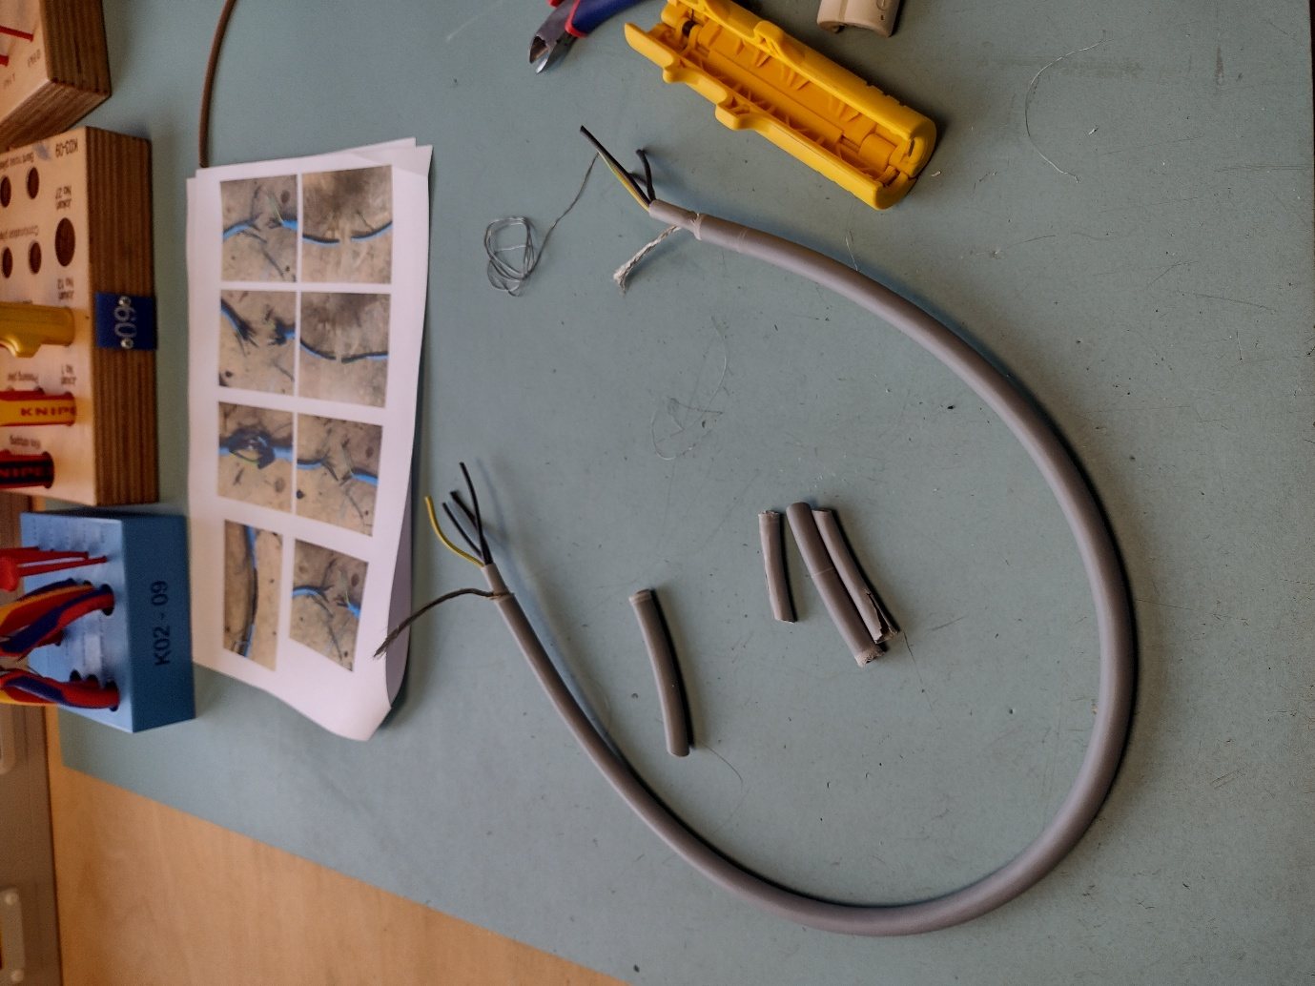

3rd step:
After that we had to remove isolation of those 4 wires and prepare them for soldering.
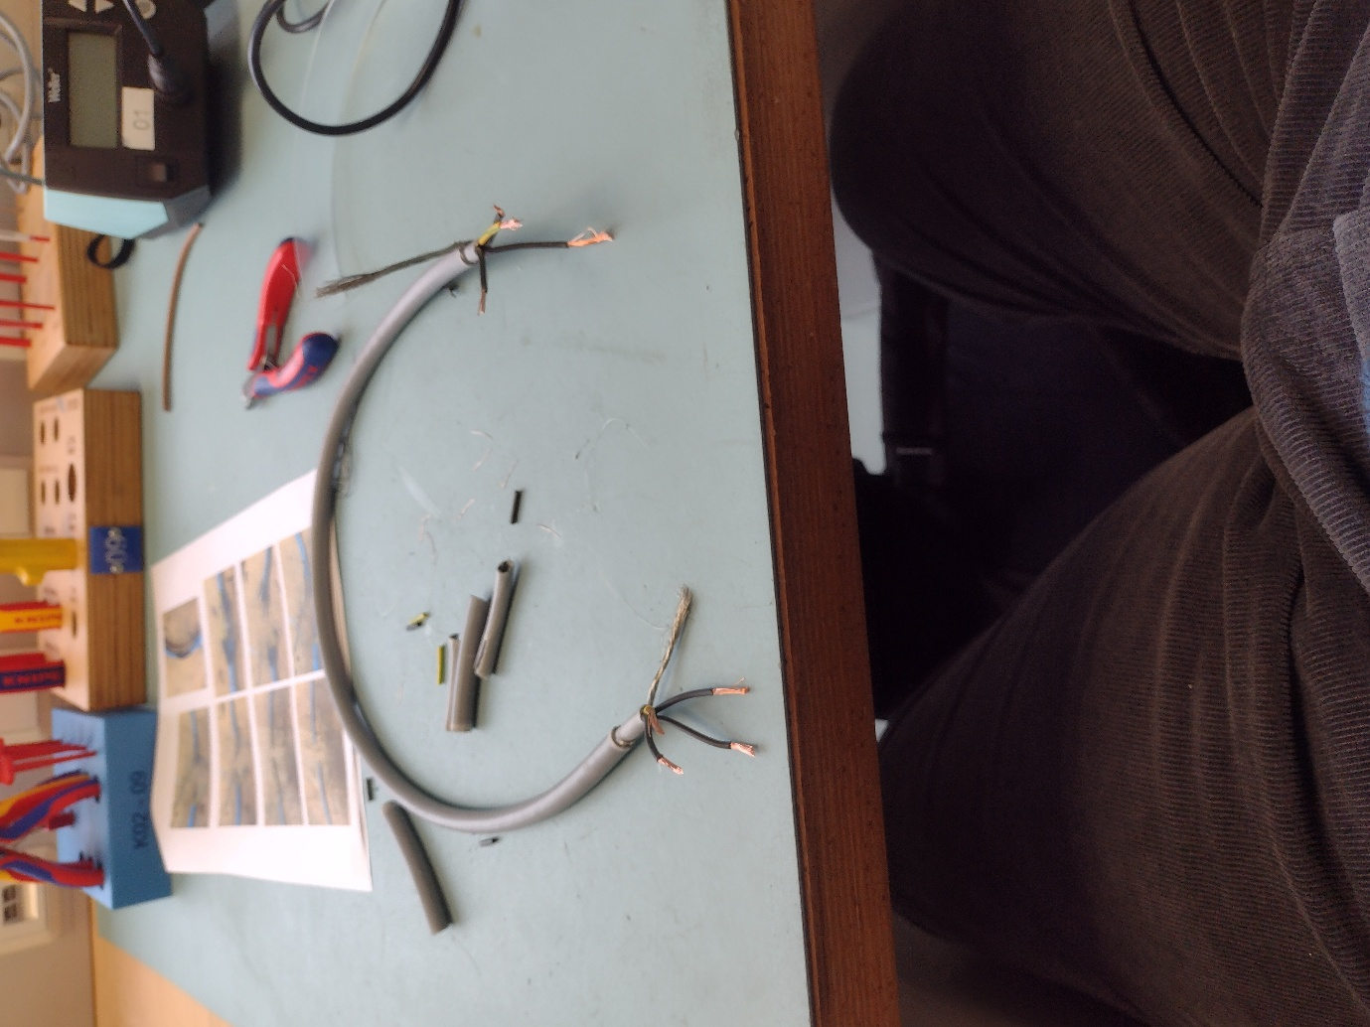

Soldering step:
Soldering involved putting brown shrinking tube from 2 sides before soldering the wires together. To solder the wires together we had to put soldering iron on one of the sides and then reheat this part with new soldering iron and put them together, then hold them until the iron solidifies and bond becomes permanent. After that we used heaters to shrink the brown tubes around the wiring.
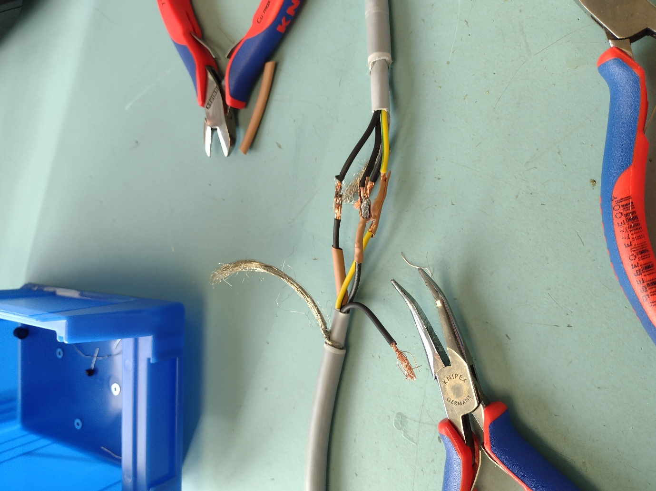

Result:
Due to lack of personal skill and practice with soldering wires I could not finish the step in this time having this as the final result:


- Sensors 1
Last week on Monday while other group was presenting we had a workshop where we had to install first sensor and 16 bit to analog converter. We obtained them and soldered together, then inserted into the printed circuit board:
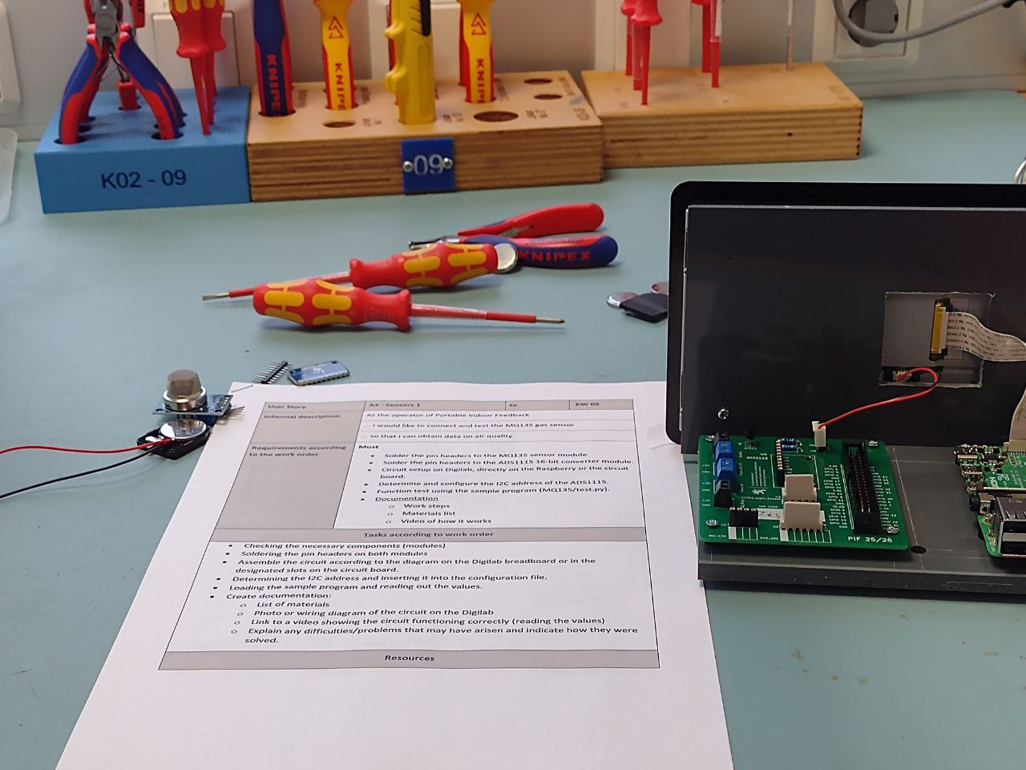
End result:
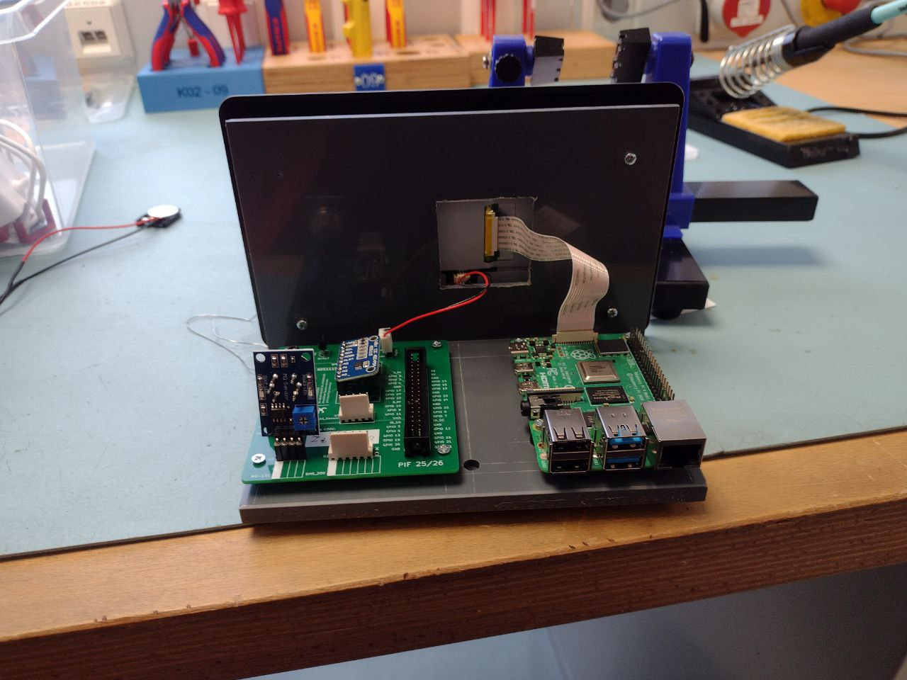
- Website
Planning of the website.
First and foremost I have made sure to always include a file with connection function in it to be always connected to database.
Next part of the planning was to fill in the data of our databases for which I have used AI systems to provide me with dummy data, the database that I have used was provided to us as a solution to the L2 to make sure that everything works correctly.
The first 2 webpages that I created and enabled were login.php and create_account.php that had the simplest functionality to implement. After implementing login and registration I implemented home page with redirects back to login page in case the user is not logged in. Then I worked on stations.php and enabled functions such as – adding a station, editing station and deleting the station. After creating stations.php I created user_page.php to allow users to manage their accounts. After that I moved on to measurement.php where I have enabled reading from the database into the table to be able to read the data from the stations. After that I started to work on friend request system – it required changes in configuration of the database, the change was to add “status” column which would have allowed to differentiate between the states of friendship, when I implemented requests – I started to work on handling them through php, I used reading database as a main system to secure the status and change it, after finishing with friend requests I have started to implement collection.php. When working on collection.php I spent a lot of time implementing friend sharing system that required me to firstly list out accessible collections, then it requires me to pick out the correct measurement from the database and the hardest of it all was to handle sharing user’s collections with their friends due to complications of using non-standard sql functions, the next hardest thing was to implement datetime selection of the output of Collection. After that I started to work on adminpage.php where I quickly implemented all the fill ins, edits and deletions – as this website reuses almost everything from the previous webpages.

